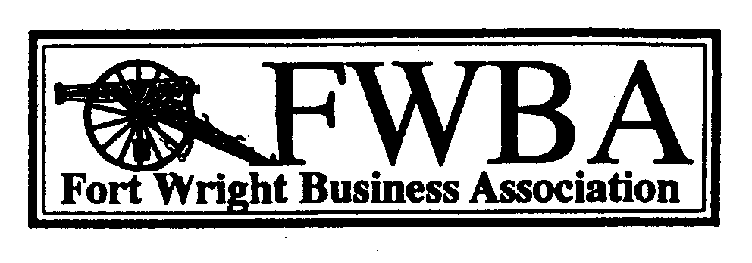
The purpose of the Fort Wright Business Association is to enhance the value of having a business in Fort Wright by fostering communications between the City and the business community, by promoting and serving local needs, and by providing the membership with useful services and programs.
Member Benefits
- The exchange of business and trading knowledge between members.
- To provide networking opportunities with other local business people, community leaders, and governmental representatives at our quarterly meetings.
- To act as a representative body in all matters that may affect businesses at either a local, state or federal level.
- To work with all government bodies and organizations to improve business conditions and opportunities.
- Enhance business conditions in the City of Fort Wright and promote a favorable image of the region.
- Profile your business in the newsletter with an in-depth description of your products and services. Receive member discounts on advertising rates in the newsletter.
- Your business will be listed on the website with a complimentary link to your site.
---------------------------------------------------------------------------------------------------------------
Member Application
Yes, I want to join the Fort Wright Business Association.
Company Name______________________________________________________________________
Representative’s Name__________________________________ Title___________________________
Address_____________________________________________________________Zip______________
Phone_____________________________________ Fax______________________________________
Representative’s email_____________________________ Website_____________________________
Products/services_____________________________________________________________________
___________________________________________________________________________________
Member Referral______________________________________________________________________
Annual Dues $100
Associate Membership $75
Make check payable to: Fort Wright Business Association
1881 Dixie Highway #125, Fort Wright, KY 41011
info@fwba.net | www.fwba.net
Fort Wright Business Associations official form of communication is Internet E-mail

